**Computer Network**

**Lab 1: Wireshark Introduction**

***Lecturer: Mr. Nguyễn Mạnh Thìn***

***Student: Trần Quốc Anh - 1852247***

1. **List 3 different protocols that appear in the protocol column in the unfiltered packet-listing window in step 7 above.**

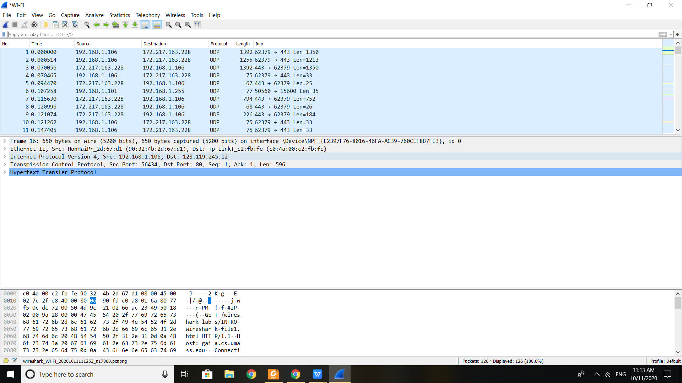

1. **How long did it take from when the HTTP GET message was sent until the HTTP OK reply was received?**

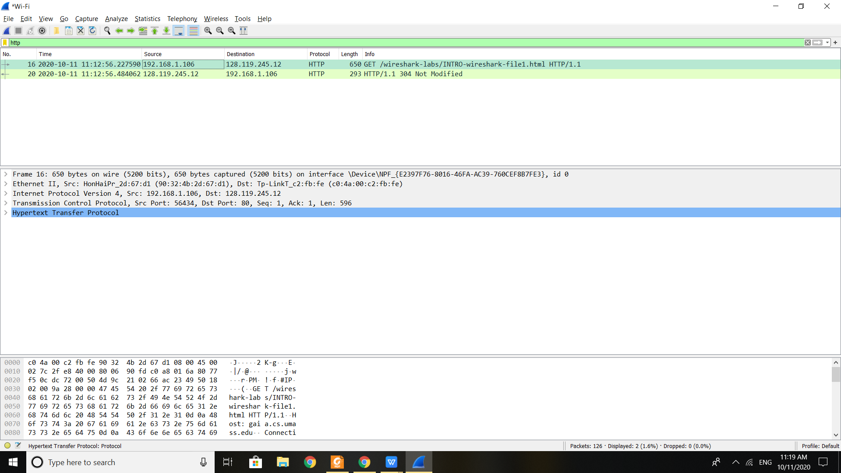

Time when HTTP GET message was sent until the HTTP OK reply was receive is:

56.484062 - 56.227590 = 0.256472

1. **What is the Internet address of the gaia.cs.umass.edu (also known as wwwnet.cs.umass.edu)? What is the Internet address of your computer?**

As the picture above:

- The Internet address of the gaia.cs.umass.edu is: 128.119.245.12

- The Internet address of my computer is: 192.168.1.106

1. **Print the two HTTP messages (GET and OK) referred to in question 2 above.**

